**Step 1:**

**Distinguish between a fresh plate and your bacterial or yeast sample.**

* Hold plates up to a bright background, and pan back and forth watching the glare on the agar
* Bacteria looks like a cloudy film unevenly dispersed over the surface
* Your fresh plate should be almost clear with a slight tint.

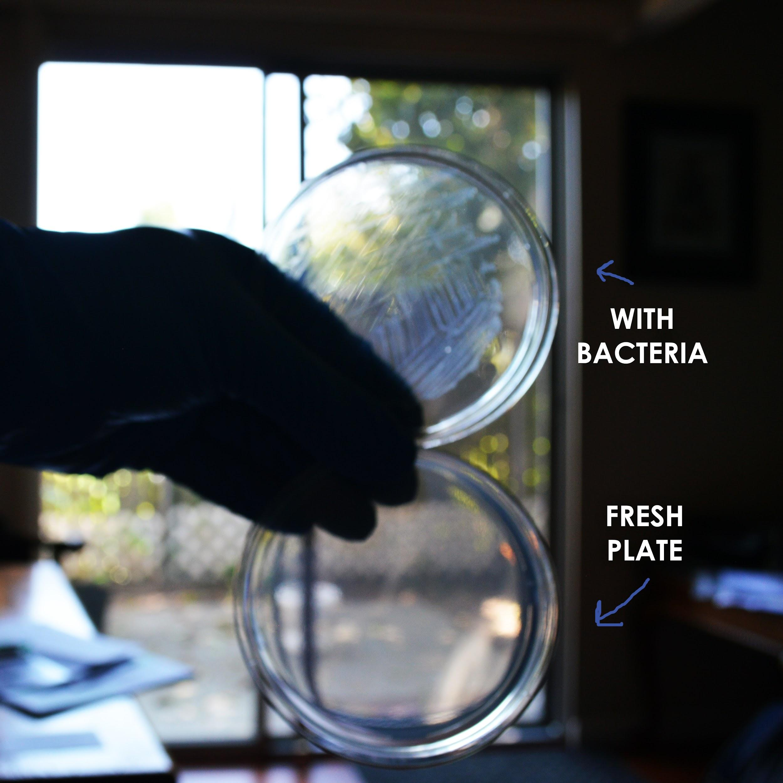

**Step 2:**

**Retrieve bacteria with inoculating loop**

* Hold loop parallel to plate surface
* Gently glide over bacterial colonies trying to gather and group them on the loop.

*DO NOT PRESS TOO HARD OR LOOP WILL BREAK AGAR*

* A milky goo will be visible on the loop if performed correctly

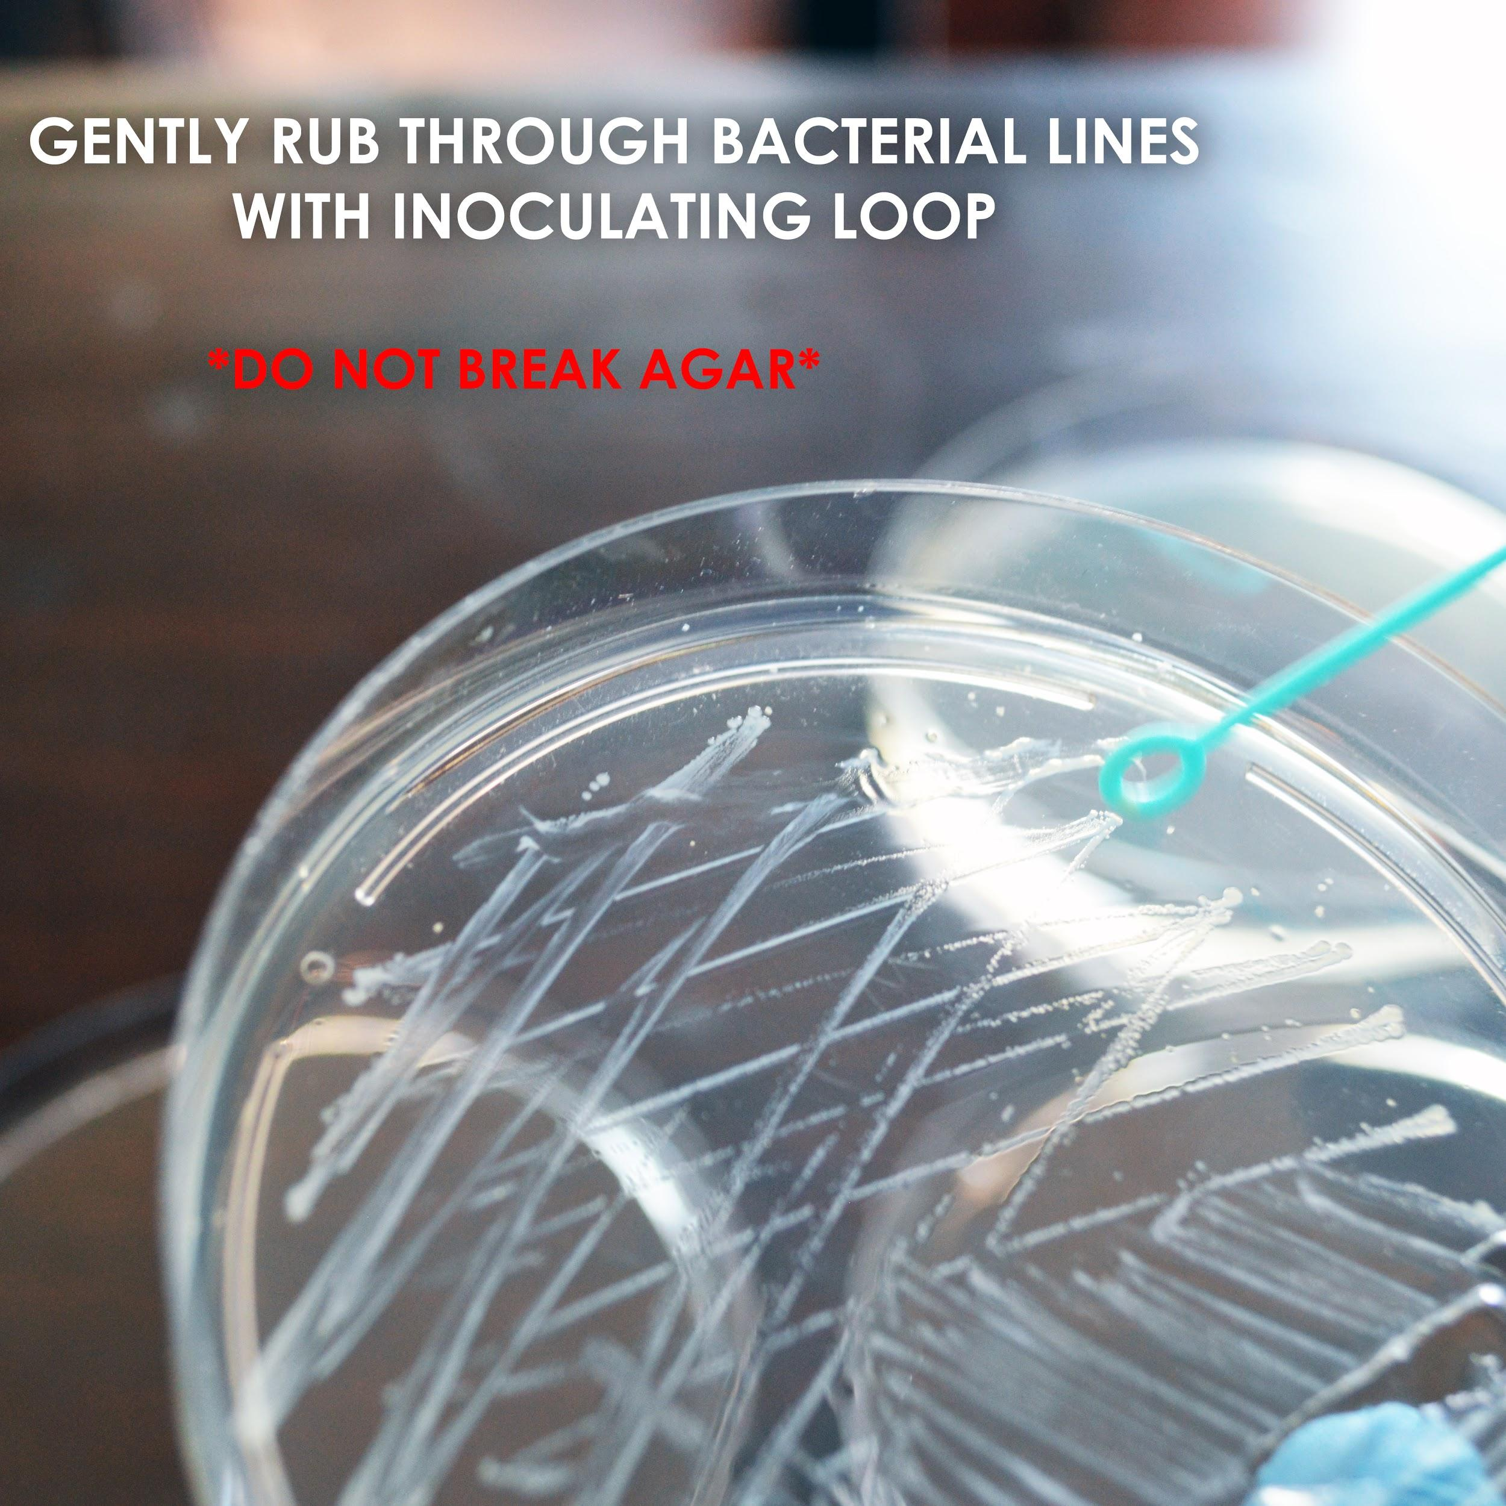

**Step 3:**

**Apply bacteria to fresh plate by spreading**

* Hold loop with bacterial sample parallel to fresh plate
* Gently rub loop across surface spreading bacteria thinly throughout
* Flip loop on other side or even gently drag edges across plate if visible bacteria still needs to be delivered.
* You should be able to see the lines you made on the surface when you hold the plate like the test you did in Step 1.

